Lab 4 Architecture
Team / student | Ammar Mohamed Fathy (1620240474), working alone
Application | Facebook (class proposal, not the real company's architecture)
Feature | React to a post
Lab 3 Specification | https://linear.app/ammar-mohamed74/document/lab-3-specification-35c3de2473b3
Linear project | https://linear.app/ammar-mohamed74/project/1620240474-facebook-post-workflow-e42ada21eea2/overview
Editable diagrams | Ammar-Lab4.drawio (attached to the design review issue AMM-34)
Issue links | Design review: https://linear.app/ammar-mohamed74/issue/AMM-34/review-the-reaction-feature-architecture  Implementation: https://linear.app/ammar-mohamed74/issue/AMM-32/build-the-reaction-action  Test: https://linear.app/ammar-mohamed74/issue/AMM-33/run-the-reaction-tests

1. Architecture record
Feature, actors, scope. The feature is React to a post. Actors: User (a sample user) and the Application Server. In scope: reacting to a Published post, removing a reaction, showing counts per reaction type (Like, Love, Haha). Out of scope: notifications, reactions on comments, custom emoji, showing who reacted, real accounts.
Three S rules (from the Lab 3 Specification)
- S1 (success): When a user selects reaction type T on a Published post, if the user has no stored Reaction on that post, the system must store one Reaction (postId, userId, T) and show the count of T on that post increased by 1.
- S2 (refusal): When a user selects a reaction type on a post, if the post does not exist or is not Published, the system must store no Reaction, leave all counts unchanged, and show the message "Post is not available".
- S3 (repeated request): When a user selects reaction type T on a post, if the user already holds a Reaction of type T on that post, the system must delete that Reaction and show the count of T decreased by 1.
Quality target Q2. With sample data and 20 concurrent sample users in the course test environment, each selecting a reaction on a different Published post once, 95% of select requests finish within 1 second. Finished means the Reaction is stored and the new count is displayed.
World assumption W2. The sample-user selector identifies the acting user correctly on every request. Effect on the design: the server takes the caller identity from its own session, never from the request body, and checks it before any rule runs (the access check in the Sequence view). The database also holds a unique key on (postId, userId), so even if a request were misattributed, a user could never hold two Reactions on one post.
Constraints
ID | Constraint | Effect on choices
C1 | Limited course time and team skills (no coding is required in this lab, and any later build is small). | Prefer one simple server over several services.
C2 | Hosting is a local course/test machine; no paid cloud and no real accounts. | All three tiers run on one machine; no scaling infrastructure is planned.

Open decisions
ID | Decision | Owner | Review date
OD1 | Replace a held reaction with a different type (Like to Love)? Would add rule S4 and a replace step in the Reaction Service. | Ammar Mohamed Fathy | 2026-10-28 (proposed)
OD2 | Programming language, framework, and database product (unknown; marked undecided in the diagrams). | Ammar Mohamed Fathy | 2026-10-28 (proposed)
OD3 | Exact hosting machine for the class demo (unknown). | Ammar Mohamed Fathy | 2026-10-28 (proposed)

2. Structure: four diagrams
All four diagrams are pages of one draw.io file and use the same names: User, Web Client, Application Server, API Handler, Reaction Service, Post Service, Data Access, Reaction Database.

Context view
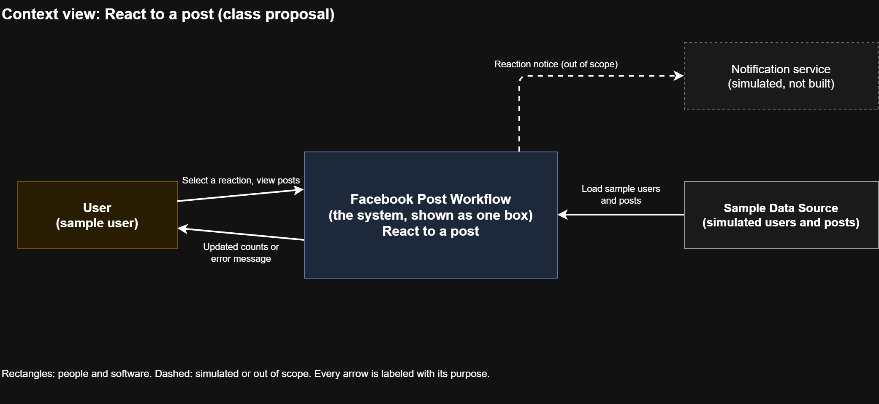
Figure 1 — Context view: the system as one box, with the user and external systems outside.
The system is one box. The User and the simulated Sample Data Source sit outside. The notification service is simulated and not built, so it is dashed. Every arrow states its purpose.

Application view
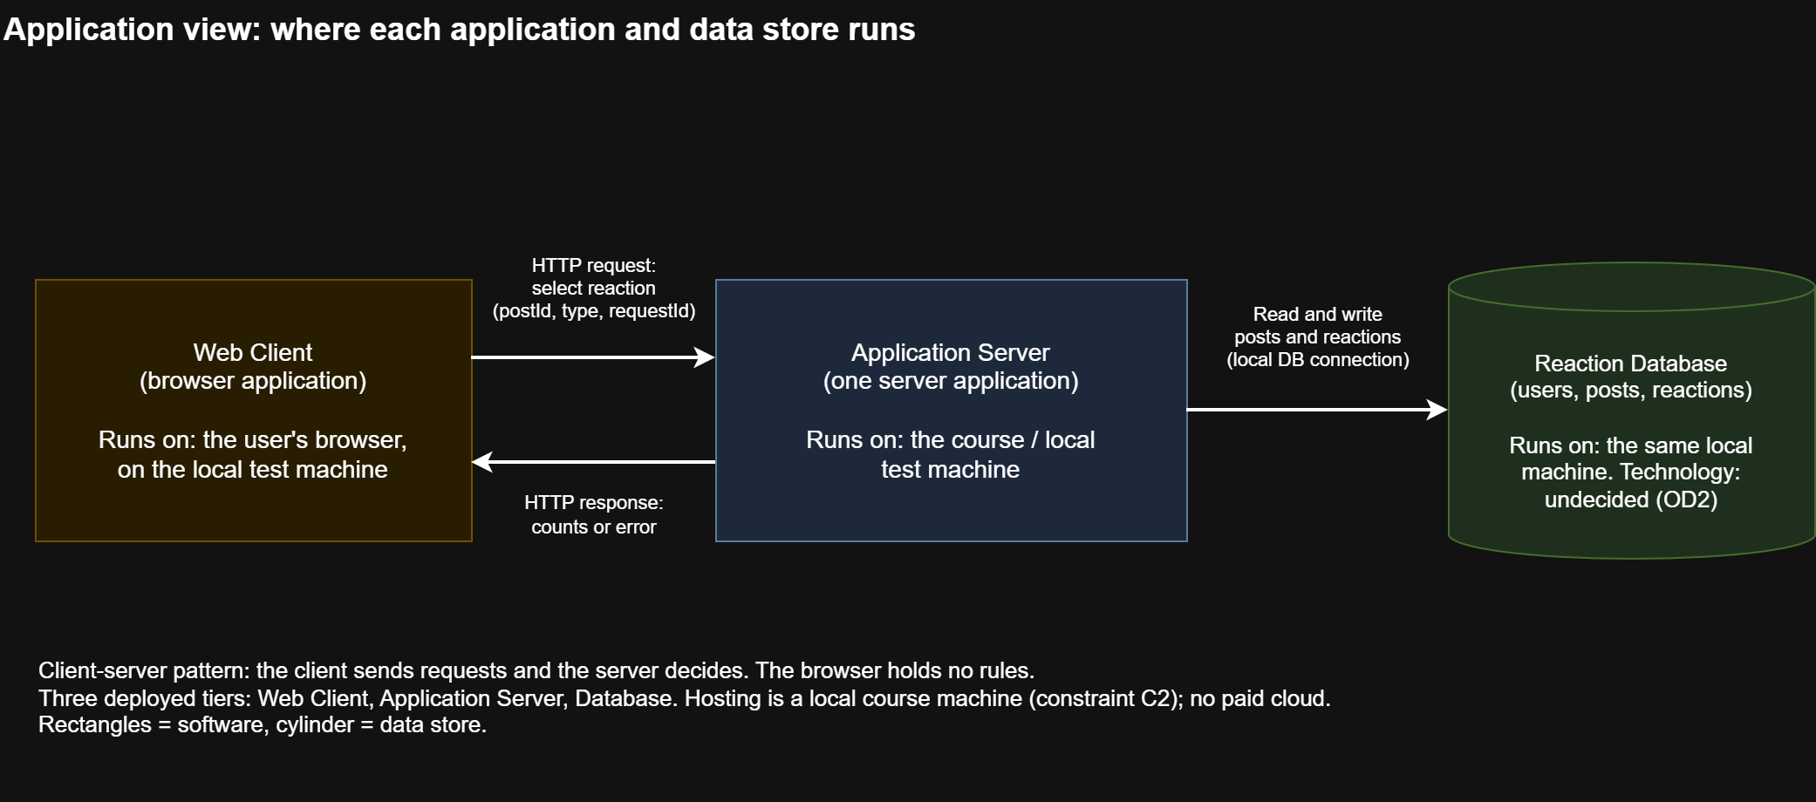
Figure 2 — Application view: client, server, data store, and where each runs.
Web Client runs in the user's browser on the local test machine. Application Server runs on the course/local machine. Reaction Database runs on the same machine, and its product is undecided (OD2). Network connections: HTTP between client and server, a local database connection between server and database.

Component view
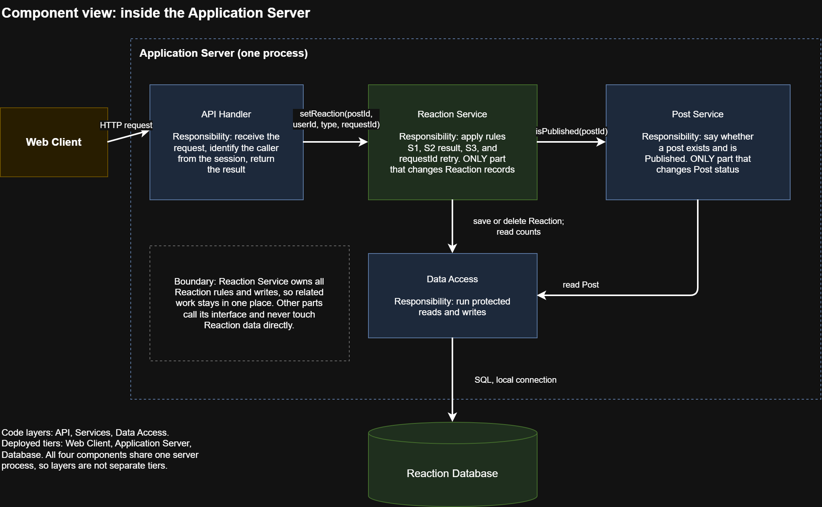
Figure 3 — Component view: four logical parts inside the Application Server.
Component | Main responsibility | May change these records
API Handler | Receive the request, identify the caller from the session, return the result. | None
Reaction Service | Apply S1, S2 (using the Post Service answer), S3, and requestId retry handling. | Reaction (the only part allowed to change it)
Post Service | Say whether a post exists and is Published. | Post status (the only part allowed to change it)
Data Access | Run protected reads and writes against the database. | None itself; writes only on behalf of the owner above

Boundary that keeps related work together. The Reaction Service owns every Reaction rule and write. Other parts call its interface and never change Reaction data directly. A change to reaction rules, such as OD1, therefore touches one component and reduces dependence on the rest.
Code layer versus deployed tier. The code layers are API, Services, and Data Access. The deployed tiers are Web Client, Application Server, and Database. The four components share one server process, so the layers are not separate tiers.

Sequence view
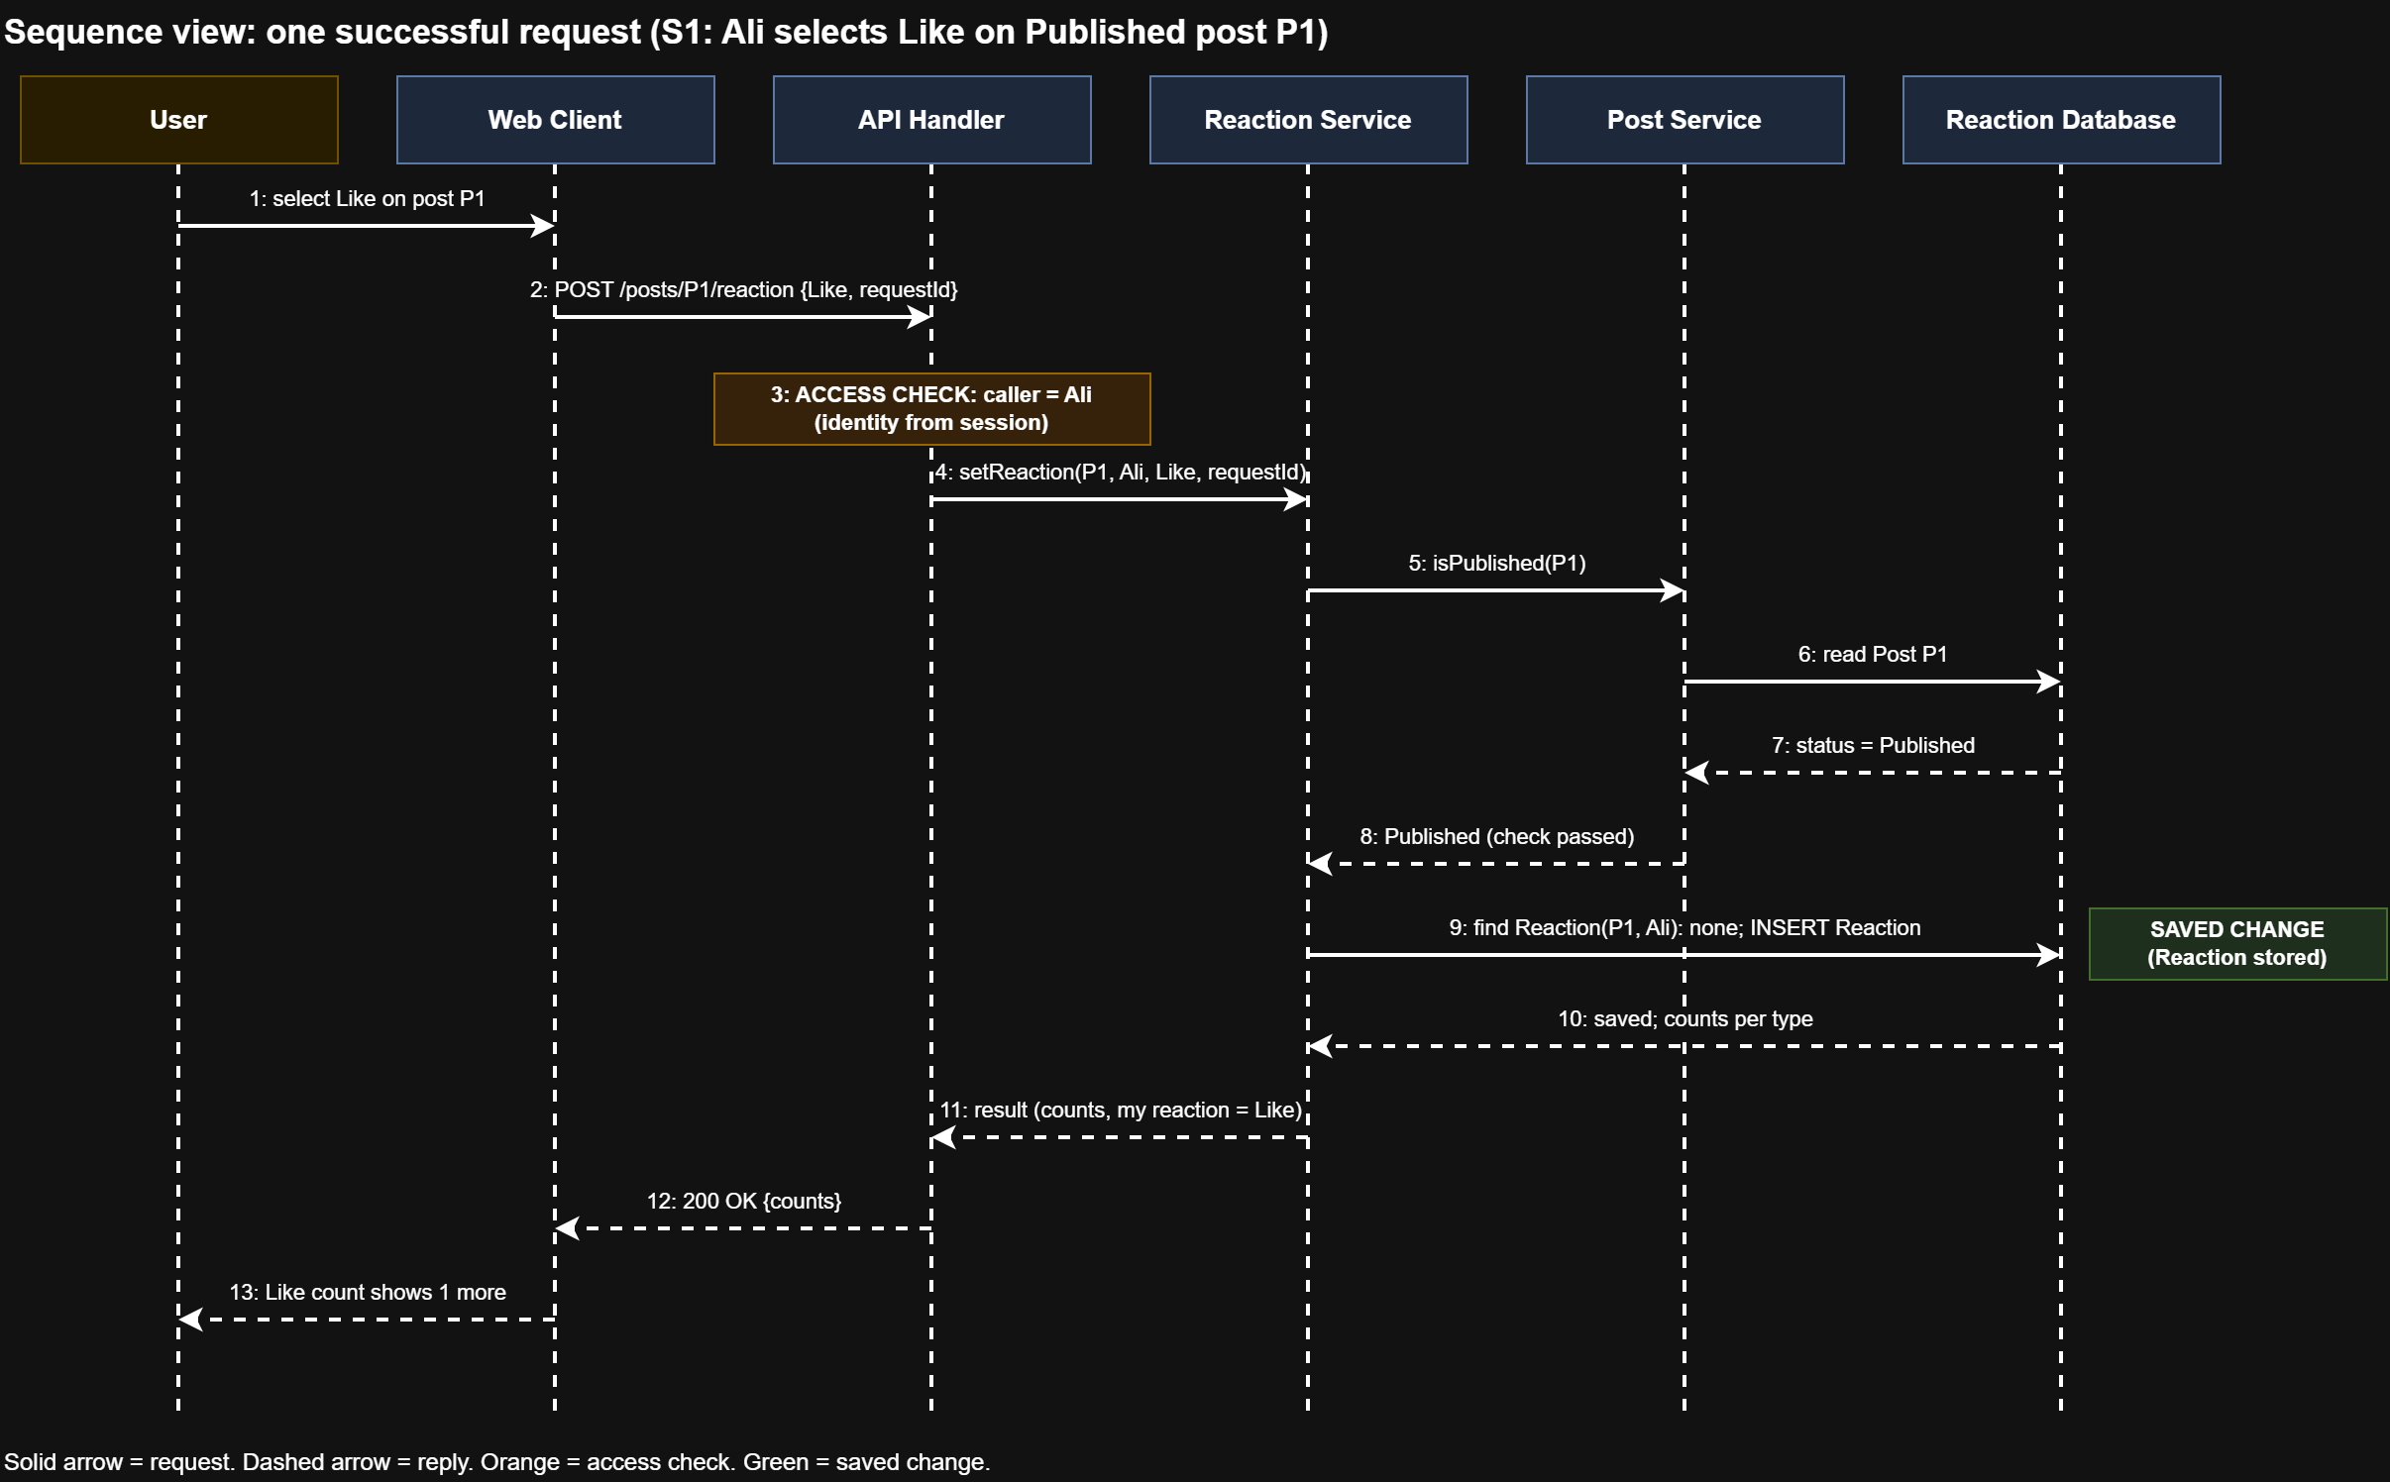
Figure 4 — Sequence view: one successful request (S1).
Failure paths (added after the peer review). The figure shows the success path only. If the caller has no session user, the API Handler stops at the access check and returns 401 "User not identified" without calling the Reaction Service. If the Post Service answers that the post does not exist or is not Published, the Reaction Service returns 404 "Post is not available" (S2) before any write, so nothing is saved.

3. Architecture choices
Pattern used: client–server, with layers inside the server. It applies between the Web Client and the Application Server: the client sends the request and the server decides, which keeps S1 to S3 in one place. Layers apply inside the server (API, Services, Data Access). No other pattern is added.
Decision compared: how to structure the server.
 | Option A: one modular server | Option B: separate services
Description | API Handler, Reaction Service, Post Service, and Data Access in one process. | Post Service and Reaction Service run as two deployed services that call each other over the network.
Benefit | Simple to build and test; one call inside the process meets Q2 easily; fits team time. | Each service could change and scale on its own.
Cost | Everything deploys and fails together. | Extra network calls, more setup, and more failure cases.
Rule or constraint that matters | C1 (time and skills), Q2 (1 second). | Q2 (extra calls cost time), C1 and C2 (more to host).

Selected: Option A. Reconsider if the Q2 test fails because of the Post Service check, or if the project later needs separate hosting for posts and reactions.

4. Behavior and failure

Interface of the main request
Item | Definition
Interface | setReaction(postId, reactionType, requestId)
Input | postId (an existing post id); reactionType (Like, Love, or Haha); requestId (a unique id the client creates per button press)
Caller identity | The current sample user, read by the server from its session. Never taken from the request body (W2).
Success result | 200 OK with the counts per reaction type and the caller's current reaction (Like, Love, Haha, or none).
Error result | 404 "Post is not available" for S2.  400 "Reaction type is not supported" for any other type.  401 "User not identified" when the session has no user.

Note: the 400 and 401 results are design decisions not covered by S1 to S3. They are listed for confirmation in the design review.

Two risks and their tests
 | Risk 1: competing requests | Risk 2: lost response and retry
What happens | The same user sends two requests for the same post at the same moment (for example two browser tabs). | S1 succeeds but the response is lost. The client retries the same press.
Broken S rule | S1 and S3: the user could end with two stored Reactions, or a count that does not match what is stored. | S3: the retry would look like a second press and delete the Reaction the user just made.
Proposed protection | Unique key on (postId, userId). The "check then write" runs in one database transaction. Only the Reaction Service writes. | The client sends a requestId. The server saves the result per (userId, requestId). A retry with the same requestId returns the saved result and makes no second change.
Test | RT1  Setup: Ali, Published post P1, no reactions.  Steps: 1. Send two Like requests with different requestIds at the same time. 2. Read the stored Reactions for (P1, Ali). 3. Read the Like count.  Expected: 0 or 1 stored Reaction, never 2; the Like count equals the stored number; neither request returns an unhandled error. | RT2  Setup: Ali, Published post P1, no reactions.  Steps: 1. Send Like with requestId R1. 2. Drop the response in the test harness. 3. Resend Like with R1. 4. Read the stored Reaction and count. 5. Send Like with a new requestId R2.  Expected: after step 3 the Reaction still exists, the count is 1, and the response equals the first one. After step 5 the Reaction is deleted and the count is 0 (S3).
Result | Not run | Not run

How Q2 will be measured. Conditions: sample data, 20 sample users, 20 Published posts, 0 existing reactions, course test machine. Method: a script (tool undecided, OD2) starts 20 requests at the same moment, one per user on a different post. For each request it records the start time and the time the response with the new count arrives. Pass: at least 19 of 20 requests (95%) take 1000 ms or less. Repeat 5 runs, deleting all reactions between runs, and record the machine used. Result: Not run.

5. ADR 001
Field | Entry
Title | ADR 001: Use one modular server for the reaction feature
Status | Proposed
Context | Rules S1 to S3 must run in one consistent place. Q2 needs 95% of requests within 1 second with 20 users. W2: the sample user is identified correctly. C1: limited time and skills. C2: one local machine.
Options | A: one modular server with API Handler, Reaction Service, Post Service, and Data Access in one process.  B: separate Post and Reaction services calling each other over the network.
Decision | Choose Option A. It is simpler, avoids extra network calls that cost time against Q2, and fits C1 and C2.
Consequences | Cost: all components deploy and fail together, and only the whole server can scale. Remaining risk: concurrent requests (Risk 1) and lost responses (Risk 2) need the protections above. Q2 is not yet verified. The refusal path (404) and the access-check path (401) must stop the request before any write.
Evidence needed | Tests RT1, RT2 and the Q2 measurement (T7), all Not run.
Open decisions | OD1, OD2, OD3 (section 1): owner Ammar Mohamed Fathy, review date 2026-10-28 (proposed).

6. Linear issues
One new issue (AMM-34) and two updated Lab 3 issues (AMM-32, AMM-33). The texts are in Appendix A. Use related links for connections; add a blocking link only where work must wait.
Issue | Action | Owner | Links and cited S rules
AMM-34 Review the reaction feature architecture (new) | Created. Lifecycle: Design. Status: Todo. | Ammar Mohamed Fathy | Related to AMM-32 and AMM-33; blocks AMM-32 (building waits for the review decision). Cites S1, S2, S3, Q2. Links: Lab 4 Architecture, ADR 001. Attach Ammar-Lab4.drawio.
AMM-32 Build the reaction action | Update (no duplicate). | Ammar Mohamed Fathy | Add component, interface, and design work. Link the Lab 4 Architecture document and ADR 001. Cites S1, S2, S3.
AMM-33 Run the reaction tests | Update (no duplicate). | Ammar Mohamed Fathy | Add RT1, RT2, and the Q2 plan. Related to the design review issue. Stays blocked by AMM-32 for execution; planning can start now.

AMM-32 and AMM-33 stay open (Todo) until the work is built and the tests are run.

7. Peer review and submission
Field | Entry
Reviewer | Saif Ali, 21/10/2026
Request traced | Select Like on P1 (the Sequence view)
Finding | Missing failure path: the Sequence view traces only the success request. It does not show what happens when the post is not Published (S2) or when the caller is not identified, so it is unclear which component stops the request before a write.
Correction and reason | Added the failure paths under the Sequence view and in ADR 001: the API Handler returns 401 before calling the Reaction Service, and the Reaction Service returns 404 "Post is not available" before any write. Reason: S2 is a rule of the specification, so the design must show who enforces it.
Recorded in | The design review issue (Linear), as a comment and my reply

Submission checklist: architecture document with four diagrams (PNG at 200%), the editable .drawio file attached to the design review issue, two options, ADR 001, two risk tests, the Q2 test plan, reviewer name (Saif Ali) and the review exchange, and the three issue links. Check that the instructor can open everything.

Appendix A: texts to paste into Linear

A1. New issue AMM-34: Review the reaction feature architecture
Owner: Ammar Mohamed Fathy Lifecycle: Design Status: Todo Priority: High
Links: related to AMM-32, AMM-33. Blocks AMM-32.
Documents: Lab 4 Architecture, ADR 001. Attach Ammar-Lab4.drawio.
Cites: S1, S2, S3, Q2.
Purpose: review the proposed architecture for "React to a post" before building.
Required:
1. A recorded review by another team (they trace one request through the four diagrams and record one missing rule, unclear responsibility, or failure risk as a comment here).
2. My corrections and reasons, posted as a reply, with the diagrams and ADR 001 updated.
3. A decision on the open risks (competing requests, lost response) and on OD1, OD2, OD3, each with an owner and a review date.
Keep this issue open until the review and decisions are recorded.

A2. Update to AMM-32 Build the reaction action (add to the description)
Design work (Lab 4): see Lab 4 Architecture and ADR 001. Cites S1, S2, S3.
Component: Reaction Service (inside the Application Server). It is the only component allowed to change Reaction records.
Interface: setReaction(postId, reactionType, requestId). Caller identity comes from the server session.
Results: 200 with counts and the user's current reaction; 404 "Post is not available"; 400 "Reaction type is not supported"; 401 "User not identified".
Must implement: unique key on (postId, userId); check-then-write in one transaction; saved result per (userId, requestId) so a retry makes no second change.
Related to the design review issue (blocked until its decision).

A3. Update to AMM-33 Run the reaction tests (add to the description)
Risk tests (Lab 4) - Result: Not run
RT1 competing requests: Ali, Published post P1, no reactions. Send two Like requests with different requestIds at the same time. Expected: 0 or 1 stored Reaction for (P1, Ali), never 2; Like count equals the stored number; no unhandled error.
RT2 lost response: Ali, P1, no reactions. Send Like with requestId R1, drop the response, resend R1. Expected: Reaction still exists, count 1, same response. Then send Like with new requestId R2. Expected: Reaction deleted, count 0 (S3).
Quality measurement plan for Q2 - Result: Not run
20 sample users, 20 Published posts, 0 reactions, course test machine. A script sends 20 requests at the same moment, one per user on a different post, and records the time until the new count arrives. Pass: at least 19 of 20 (95%) take 1000 ms or less. Repeat 5 runs, delete reactions between runs, record the machine.
Related to the design review issue. Execution stays blocked by AMM-32; planning can start now.

A4. Review exchange (comment and reply in the design review issue)
Comment (Saif Ali):
Review of Lab 4 Architecture. I traced "select Like on P1" through the four diagrams. Missing failure path: the Sequence view shows only the success request. It does not show what happens when the post is not Published (S2) or when the caller is not identified, so it is unclear which component stops the request before a write.
Reply (Ammar Mohamed Fathy):
Thanks. I added the failure paths under the Sequence view and in ADR 001. The API Handler returns 401 "User not identified" before calling the Reaction Service, and the Reaction Service returns 404 "Post is not available" before any write. Reason: S2 is a rule of the specification, so the design must show which component enforces it.

